**R Code for Examples in the book**

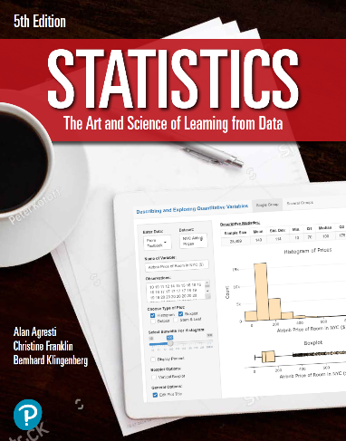

***“Statistics: The Art and Science of Learning from Data”***

**by Agresti, Franklin and Klingenberg, 5th edition**

**Chapter 6**

**Example 10: Students Who Get B – Using z-Scores for Interval Probabilities**

## To find the percentage of students that earn a B

pnorm(90, mean = 83, sd = 5) - pnorm(80, mean = 83, sd = 5)

## [1] 0.6449902

## You can also use z-scores to compute the same percentage

z90 <- (90 - 83) / 5  
z80 <- (80 - 83) / 5  
pnorm(z90) - pnorm(z80)

## [1] 0.6449902